ABSTRACT

In a world where innovation is the driving force behind progress, it is crucial to protect the fruits of intellectual labour. However, the lack of awareness surrounding Plant Patents and the complexities of the patenting process often hinder individuals from safeguarding their botanical innovations. To bridge this knowledge gap, we have embarked on a mission to develop a comprehensive and user-friendly website, serving as a beacon for those navigating the intricate landscape of plant patent registration.

The Need for Awareness:
Plant Patents play a pivotal role in fostering innovation within the realm of agriculture, horticulture, and botanical sciences. Despite their significance, many innovators remain unaware of the potential avenues these patents open for them. Our website aims to address this gap by providing a wealth of information on plant patents and patenting processes, ultimately empowering individuals to protect their unique plant varieties.

Comprehensive Guide:
Our website is more than just a digital platform; it is a comprehensive guide designed to demystify the complexities of plant patent registration. We've curated a wealth of accessible information on diverse registration methods, ensuring that users have a clear understanding of the different paths available to them. By consolidating relevant details in one user-friendly space, we aim to alleviate the stress associated with the patenting process.

Empowering Innovators:
At the heart of our initiative is the sincere desire to empower innovators. We believe that every unique plant variety deserves protection, and the patenting process should not be a daunting obstacle. Our website serves as a dedicated space to guide individuals through each step of the patenting journey, ensuring that they can navigate the process with confidence.

Clear and Accessible Paths:
Navigating the intricacies of patenting can be overwhelming, but our platform offers clear and accessible paths. We've broken down the patent application journey into digestible steps, providing users with a roadmap to success. Whether you are a seasoned researcher or a budding horticulturist, our website is designed to cater to individuals at every stage of their innovation journey.

Streamlining the Application Process:
The goal is not just to provide information but to streamline the patent application process. We understand that time is of the essence for innovators, and our platform is geared towards enhancing accessibility and efficiency. By offering a user-friendly interface and actionable guidance, we aim to expedite the patenting journey, ensuring that innovations receive the protection they deserve.

Fostering an Innovation-Friendly Environment:
Ultimately, our vision extends beyond individual patents. We aspire to contribute to the
creation of an innovation-friendly environment where plant breeders, researchers, and horticulturists feel supported and encouraged to bring forth their unique contributions. Through our informative website, we hope to play a role in shaping a future where innovative ideas flourish and are safeguarded for the benefit of generations to come.

Our website stands as a testament to our commitment to demystify plant patents, making the patenting process more accessible for all. We invite you to explore the wealth of information we've compiled and embark on a journey towards securing the future of your botanical innovations. Together, let's cultivate a landscape where innovation thrives, protected by the branches of knowledge and guided by the roots of understanding

INDUSTRIAL VERTICAL AND DOMAIN TECHNOLOGY
Agriculture
In the ever-evolving landscape of agriculture, innovation is the key to sustainable growth. However, a significant obstacle often stands in the way of agricultural pioneers – the lack of awareness about Plant Patents and the intricate processes involved in securing them. Recognizing this gap, our initiative steps into the field with an informative website tailored to the unique needs of the agricultural community. This digital hub is not just a guide; it's a compass navigating innovator through the complexities of plant patent registration.

The Agricultural Challenge:
Agricultural innovation, from crop breeding to horticultural breakthroughs, deserves protection. Yet, many in the agricultural sector remain unaware of the avenues available to safeguard their plant varieties. Our mission is to bring about a transformation by providing a centralized resource, a virtual agricultural ally, guiding farmers, researchers, and horticulturists towards securing their innovations.

Comprehensive Agricultural Guide:
Our website is more than a digital handbook; it's a comprehensive guide crafted with the agricultural community in mind. By consolidating relevant details on diverse registration methods in a user-friendly platform, we aim to bridge the knowledge gap. From traditional farming practices to cutting-edge aggrotech, our platform caters to the varied landscape of agriculture, offering accessible information crucial for navigating the intricacies of plant patent registration
Empowering Agricultural Minds:
Agricultural innovation is at the heart of our endeavour. We understand that navigating the patenting process can be particularly daunting in the agricultural sector. Through our dedicated website, we empower individuals in agriculture to efficiently navigate and comprehend the intricacies of plant patent registration. By doing so, we seek to alleviate the stress associated with the patenting process, allowing farmers and researchers to focus on what they do best – cultivating sustainable and groundbreaking solutions for a growing world.

Securing Crop Futures:
The objective of our initiative is clear – to facilitate the patenting process for agricultural innovators. From seed developers to agribusiness entrepreneurs, our website provides comprehensive guidance through every step of the journey. By offering clear and accessible paths, we aim to ensure that the innovations and inventions in agriculture receive the necessary protection. Through plant patents, we collectively work towards securing the future of crop varieties, fostering a resilient and innovative agricultural ecosystem.

Fostering Agricultural Innovation:
Our broader goal extends beyond individual patents; it's about fostering an innovation-friendly environment within the agricultural community. By enhancing accessibility and streamlining the patent application journey, we contribute to a future where agricultural ideas are nurtured, protected, and cultivated for the benefit of global food security and sustainable farming practices.
Internet of things
This project aims to leverage the Internet of Things (IoT) to raise awareness about plant patents and simplify the patenting process through an online platform. The integration of IoT technologies will provide a user-friendly interface, making it easier for individuals to understand the significance of plant patents and navigate the patent application process seamlessly.
a. Brief Overview of Plant Patents: Explanation of what plant patents are and their significance in protecting new and distinct plant varieties.
b. Importance of Awareness: Discussing the need for increased awareness about plant patents among individuals, farmers, and horticulturists.

IoT Integration for Awareness:
a. Educational Content: Utilizing IoT devices to disseminate informative content about plant patents through various channels.
b. Interactive Workshops: Conducting virtual workshops and sessions to engage the audience and answer queries.
c. Social Media Integration: Leveraging social media platforms to share updates, success stories, and key information.

Online Platform for Patenting:
a. User-Friendly Interface: Designing a website with a simple and intuitive interface for easy navigation.
b. Step-by-Step Guidance: Providing a step-by-step guide on the plant patent application process.
c. IoT-Enabled Assistance: Integrating chatbots or virtual assistants to address user queries in real-time.

Plant Patent Database:
a. Centralized Repository: Creating a comprehensive online database of plant patents.
b. Search Functionality: Implementing a search feature for users to explore existing plant patents easily.
c. Regular Updates: Ensuring the database is regularly updated with new patent information.

Security and Confidentiality:
a. Secure Data Transmission: Implementing encryption protocols to ensure the confidentiality of user data during the patent application process.
b. Compliance with Regulations: Adhering to legal requirements and standards for handling sensitive patent-related information.

Promoting Accessibility:
a. Multilingual Support: Offering the platform in multiple languages to cater to a diverse user base.
b. Mobile Responsiveness: Ensuring the website is accessible across various devices, including smartphones and tablets.

Case Studies and Success Stories:
a. Showcasing Examples: Highlighting successful plant patent applications and their impact on agriculture and horticulture.
b. User Testimonials: Featuring testimonials from individuals who have successfully navigated the patenting process using the online platform.

Future Enhancements:
a. Incorporating Blockchain: Exploring the integration of blockchain technology for added security and transparency.
b. Collaborations with Institutions: Establishing partnerships with agricultural institutions for continuous improvement and support.

This project combines the power of IoT and online platforms to create awareness about plant patents and streamline the patent application process. By enhancing accessibility and providing valuable resources, the project aims to empower individuals, farmers, and horticulturists to protect and commercialize their unique plant varieties effectively.

CHAPTER 1
EMPATHY

In the empathy phase of design thinking, individuals immerse themselves in the user's world, actively seeking to comprehend their needs, challenges, and aspirations. Through careful observation and attentive listening, this phase establishes a profound connection with the user's viewpoint, offering crucial insights that shape the development of solutions focused on the user's experience.

In the pursuit of implementing plant genesis, this thesis serves as a guiding light, emphasizing the paramount importance of inclusivity. It goes beyond the traditional boundaries of intellectual property protection, recognizing that innovation is not the exclusive domain of the educated elite. By championing inclusivity, the research underscores the notion that even among uneducated individuals, unique ideas deserve protection from theft and exploitation. The concept of plant genesis, therefore, becomes a vehicle for democratizing innovation, breaking down barriers that may hinder the recognition and safeguarding of inventive ideas.

Central to the thesis is a profound commitment to acknowledging and upholding the inherent rights of every individual to their own inventions. In doing so, the research seeks to bridge existing gaps in understanding, especially among those with limited formal education. By dismantling the notion that innovation is reserved for the academically trained, the thesis advocates for a more egalitarian approach to intellectual property. It emphasizes the need to empower all contributors to innovation, irrespective of their educational backgrounds. This inclusive perspective not only broadens the scope of those who can actively participate in the creation of novel ideas but also underscores the belief that intellectual creativity is a universal right.

Through the lens of empathy, the thesis envisions the cultivation of an environment where intellectual creativity is not only valued but also safeguarded for the benefit of all. It recognizes that true progress is achieved when diverse perspectives and ideas, regardless of educational pedigree, are embraced and protected. By promoting an empathetic understanding of the challenges faced by those with limited education in navigating the complexities of intellectual property, the research aims to foster a more inclusive and supportive atmosphere. In doing so, it aspires to contribute to a paradigm shift where every individual, regardless of their educational background, can actively engage in the innovation process, knowing that their contributions are not only recognized but also protected for the greater good

EMPATHY MAP
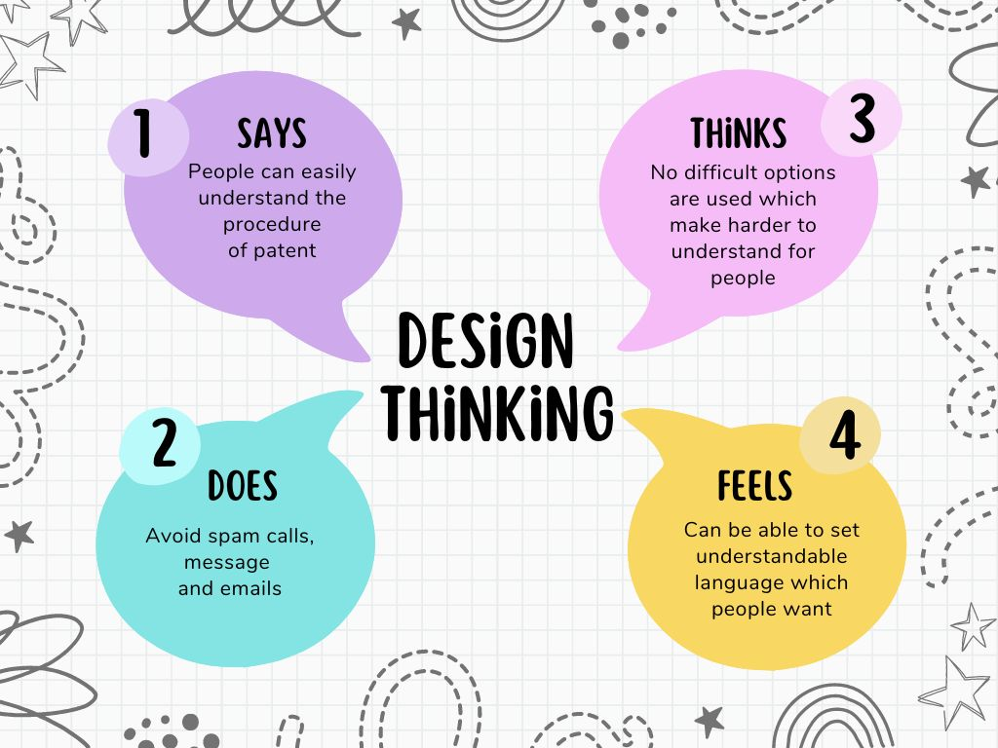

Says:
One of the cornerstones of this research lies in the belief that people can easily comprehend the intricacies of the patenting procedure. The thesis aims to break down the often-perceived complexity of patent processes, making them accessible to individuals from all walks of life. By adopting a clear and straightforward approach to explaining the steps involved in obtaining a patent, the research endeavours to demystify the procedure.
Through user-friendly language and easily digestible information, the thesis seeks to empower individuals, ensuring that the patenting process is not an exclusive realm reserved for legal experts but a journey that can be navigated by anyone with a creative idea.

In line with the inclusive philosophy, the thesis adopts a user-centric approach to patent education. Recognizing that accessibility is not just about language but also about presentation and engagement, the research incorporates interactive elements and real-world examples. Through this approach, the complexities of patent procedures are transformed into comprehensible steps, fostering a sense of confidence among aspiring innovators. By embracing the principle that understanding the patenting process should be within reach for everyone, the thesis contributes to the broader goal of building a society where intellectual property protection is not only seen as achievable but as a fundamental right for all.

Thinks:
A fundamental tenet of this research is the deliberate avoidance of convoluted language and complex jargon in explaining patent procedures. The thesis recognizes that simplicity is key to fostering widespread understanding, and, as such, it deliberately refrains from employing difficult options that might pose barriers to comprehension. By adopting clear and straightforward language, the research aims to demystify the patenting process, ensuring that individuals, regardless of their background, can easily grasp the steps involved. This commitment to simplicity is driven by the belief that accessibility should not be hindered by unnecessary complications, allowing a broader audience to engage with and navigate the patenting journey with confidence.

The user-centric approach of this thesis extends beyond language clarity to encompass a broader strategy of user-friendly education. The research integrates interactive elements, real-world examples, and intuitive explanations, ensuring that the patenting process is not only comprehensible but engaging. By consciously avoiding difficult options that might obscure understanding, the thesis empowers individuals to participate actively in the learning process. In embracing the principle that understanding patent procedures should not be an arduous task, the research contributes to building a more inclusive and informed society, where the protection of intellectual property is demystified and accessible to all.

Does:
The imperative to avoid spam calls, messages, and emails has become increasingly pronounced in our digitally interconnected world. This challenge necessitates the adoption of robust strategies aimed at preventing unwanted and potentially harmful communication. Cutting-edge technologies, such as advanced spam filters and call screening applications, play a crucial role in identifying and blocking spam attempts. Additionally, user education on recognizing phishing attempts and suspicious communication is an integral component of an effective spam prevention strategy. By combining technological solutions with user awareness, individuals can proactively shield themselves from the inconvenience and potential risks associated with spam across various communication channels.

In the quest to avoid spam, empowering users with the tools and knowledge to protect themselves is paramount. Users should be equipped with user-friendly and efficient spam-blocking applications that seamlessly integrate with their communication devices. Moreover, educational campaigns that raise awareness about the tactics employed by
spammers can help individuals identify and avoid falling victim to fraudulent communication. By fostering a collective sense of vigilance and providing accessible resources, the community at large can actively participate in the fight against spam. Ultimately, a multi-faceted approach that combines technological solutions with user empowerment is key to mitigating the pervasive issue of spam across calls, messages, and emails, ensuring a safer and more secure digital communication environment for everyone.

Feels:
The imperative to steer clear of spam calls, messages, and emails calls for the development of strategies that resonate with everyday users seeking simplicity and clarity. In navigating the digital landscape, the focus is on adopting intuitive and user-friendly solutions. Advanced spam filters, seamlessly integrated into communication platforms, serve as a shield against unwanted intrusions. Simultaneously, user education becomes a pivotal aspect, with efforts aimed at enhancing awareness on recognizing phishing attempts and suspicious communication.

By steering clear of complicated options and embracing straightforward tools, individuals can effortlessly protect themselves from the nuisance and potential risks associated with spam across diverse communication channels. In the pursuit of a spam-free digital experience, empowerment lies at the core of user-centric strategies. The emphasis shifts towards providing users with intuitive spam-blocking applications that align seamlessly with their communication devices. Additionally, educational initiatives play a pivotal role, ensuring users are well-versed in identifying common tactics employed by spammers.

By simplifying the tools and knowledge needed to combat spam, a collective effort emerges, empowering individuals to actively participate in fortifying their digital space. Striking a balance between accessible technological solutions and user empowerment is crucial, fostering a secure and user-friendly digital environment where people can navigate their communication channels without the intrusion of unwanted and potentially harmful spam.

In the pursuit of a spam-free digital experience, empowerment lies at the core of user-centric strategies. The emphasis shifts towards providing users with intuitive spam-blocking applications that align seamlessly with their communication devices. Additionally, educational initiatives play a pivotal role, ensuring users are well-versed in identifying common tactics employed by spammers. By simplifying the tools and knowledge needed to combat spam, a collective effort emerges, empowering individuals to actively participate in fortifying their digital space. Striking a balance between accessible technological solutions and user empowerment is crucial, fostering a secure and user-friendly digital environment where people can navigate their communication channels without the intrusion of unwanted and potentially harmful spam. As technology evolves, ongoing efforts to enhance user awareness and simplify spam-fighting tools will contribute to a collective defense against digital intrusions, creating a more secure and enjoyable online experience for all
CHAPTER 2
DEFINE

For this we have come with a solution to address the lack of awareness about Plant Patents and patenting processes by developing an informative website. The website serves as a comprehensive guide, offering users accessible information on diverse registration methods. By consolidating relevant details in one user-friendly platform, the website aims to alleviate the stress associated with the patenting process, empowering individuals to navigate and understand the intricacies of plant patent registration more efficiently. The objective is to facilitate the patenting process for innovators by providing comprehensive guidance through our dedicated website. By offering clear and accessible paths, the platform aims to empower individuals to successfully navigate the intricacies of patenting, ensuring that their innovations and inventions receive the necessary protection. The goal is to enhance accessibility and streamline the patent application journey, fostering a more innovation-friendly environment.

Existing system’s limitations:
One significant limitation within the current system is the lack of comprehensive information and elaboration specifically pertaining to plant patents. The existing framework fails to provide a detailed understanding of the nuances associated with securing patent protection for plant varieties. This deficiency hinders individuals, particularly in the context of agriculture and horticulture, from navigating the patenting process effectively. The absence of in-depth insights into plant patents may discourage potential innovators from pursuing this avenue for safeguarding their botanical creations.
Furthermore, the prevailing lack of awareness regarding patent processes, particularly in the Indian context, represents a noteworthy drawback. Many individuals in India remain uninformed about the intricacies of the patent system, and there is a prevailing misconception that the patenting process is arduous, exclusive, and beyond the reach of the general populace. This misconception could potentially deter innovative minds from seeking protection for their creations, limiting the growth of intellectual property within the country. Addressing these limitations is crucial for fostering a more informed and inclusive environment, where individuals in India can confidently engage in the patenting process and contribute to the protection of their valuable innovations.

Furthermore, the prevailing lack of awareness regarding patent processes, particularly in the Indian context, represents a noteworthy drawback. Many individuals in India remain uninformed about the intricacies of the patent system, and there is a prevailing misconception that the patenting process is arduous, exclusive, and beyond the reach of the general populace. This misconception could potentially deter innovative minds from seeking protection for their creations, limiting the growth of intellectual property within the country. Addressing these limitations is crucial for fostering a more informed and inclusive environment, where individuals in India can confidently engage in the patenting process and contribute to the protection of their valuable innovations. Initiatives focused on education and accessibility are essential to demystify the patenting process and encourage a broader participation in securing intellectual property rights, particularly in the field of plant varieties.

CHAPTER 3
IDEATE
Background:
In the rapidly evolving digital landscape, the need for dynamic and efficient web solutions is more crucial than ever. This project aims to leverage the power of Google Apps Script along with HTML, CSS, and JavaScript to create a versatile and responsive website. Google Apps Script provides a serverless environment, making it an excellent choice for developing web applications that seamlessly integrate with Google Workspace and other Google services.

Objective:
The primary objective of this project is to design and implement a dynamic website that fulfills specific user requirements. The website will be developed using HTML for structuring, CSS for styling, and JavaScript for enhancing user interactivity. Google Apps Script will be employed to handle server-side functionalities and interactions with Google services, allowing for a streamlined and efficient web application.

Scope of Work:
The project will involve the following key components:
- Designing a user-friendly interface using HTML and CSS.
- Implementing dynamic features and interactivity with JavaScript.
- Leveraging Google Apps Script to manage server-side functionalities and interactions with Google services.
- Ensuring responsiveness and compatibility across various devices.
- Integrating secure authentication and authorization mechanisms.

Technical Stack:
The technical stack for this project includes:
- HTML: For structuring the content and creating the web pages.
- CSS: For styling the website and ensuring a visually appealing user interface.
- JavaScript: For client-side scripting to enhance user interactivity and responsiveness.
- Google Apps Script: For server-side scripting and handling server-side functionalities.

Website Architecture:
The website will be organized into multiple pages, each serving a specific purpose. The architecture will include:
- Home Page: Providing an overview and navigation to other sections.
- User Dashboard: A personalized space for users, displaying relevant information.
- Interactive Features: Incorporating dynamic elements like forms, real-time updates, and notifications.
- Integration with Google Services: Using Google Apps Script to interact with Google Workspace or other relevant services.

By combining the strengths of Google Apps Script, HTML, CSS, and JavaScript, this project aims to deliver a robust and feature-rich website, offering a seamless user experience while integrating seamlessly with the Google ecosystem.

CHAPTER 4
PROTOTYPE
The website is built using the Google Apps Script web app that uses HTML and CSS for the front end. The web app allows users to submit information through a form, and the submitted data is then appended to a Google Sheets spreadsheet.

1. `doGet(e)` function:
- This function is a Google Apps Script function that is triggered when the web app is accessed.
- It creates an HTML template from the "Index" file, evaluates it, sets X-Frame-Options to allow all (for embedding), and returns the result.
2. `include(filename)` function:
- This function is used to include HTML or CSS files in the main HTML file.
3. `userClicked(userData)` function:
- This function is triggered when the user submits the form.
- It opens a Google Sheets spreadsheet by ID, gets the "Info" sheet, and appends a new row with the submitted user data.
4. HTML and CSS:
- The HTML code defines the structure of the web page, including navigation, sections for features, about, patent information, process, gallery, and contact.
- The CSS code provides styling for the HTML elements.
5. JavaScript:
- There's a script at the end of the HTML file that adds functionality to the web page. It includes event listeners for form submission and smooth scrolling navigation.
6. Libraries and Frameworks:
- Bootstrap and jQuery libraries are included to enhance the styling and functionality of the web page.
7. Images:
- Image URLs from Google Drive are used to display images on the web page.
8. Form Submission:
- The user's form data is captured using JavaScript when the form is submitted, and the `userClicked` function is called to handle the data.

Source code:
function doGet(e) {
var x = HtmlService.createTemplateFromFile("Index");
var y = x.evaluate();
var z = y.setXFrameOptionsMode(HtmlService.XFrameOptionsMode.ALLOWALL);
return z;
}

function include(filename){
return HtmlService.createHtmlOutputFromFile(filename).getContent();
}

function userClicked(userData){
var id = "12x0lXlBw4tzKAuWIC-In0WyLdap7XKQnlaHYDAyEVxU";
var ss = SpreadsheetApp.openById(id);
var ws = ss.getSheetByName("Info");

ws.appendRow([new Date(), userData.userName, userData.userEmail, userData.userMesg]);
}

<!DOCTYPE html>
<html lang="en">
<head>
<meta charset="utf-8">
<meta name="viewport" content="width=device-width, initial-scale=1">
<title>"Plant Genesis"</title>
<meta name="description" content="">
<meta name="author" content="">

<?!= include("CSS");?>

</head>
<body id="page-top" data-spy="scroll" data-target=".navbar-fixed-top">
<!-- Navigation
==========================================-->
<nav id="menu" class="navbar navbar-default navbar-fixed-top">
<div class="container">
<!-- Brand and toggle get grouped for better mobile display -->
<div class="navbar-header">
<button type="button" class="navbar-toggle collapsed" data-toggle="collapse" data-target="#bs-example-navbar-collapse-1"> <span class="sr-only">Toggle navigation</span> <span class="icon-bar"></span> <span class="icon-bar"></span> <span class="icon-bar"></span> </button>
</div>

<!-- Collect the nav links, forms, and other content for toggling -->
<div class="collapse navbar-collapse" id="bs-example-navbar-collapse-1">
<ul class="nav navbar-nav">
<li><a href="#features" class="page-scroll">Features</a></li>
<li><a href="#about" class="page-scroll">About</a></li>
<li><a href="#patent" class="page-scroll">Patent</a></li>
<li><a href="#process" class="page-scroll">Process</a></li>
<li><a href="#contact" class="page-scroll">Contact</a></li>
</ul>
</div>
<!-- /.navbar-collapse -->
</div>
</nav>
<!-- Header -->
<header id="header">
<div class="intro">
<div class="overlay">
<div class="container">
<div class="row">
<div class="intro-text">
<h1>Plant Genesis</h1>
<p>Your Journey to Botanical Innovation Starts Here.</p>
</div>
</div>
</div>
</div>
</div>
</header>
Prototype:
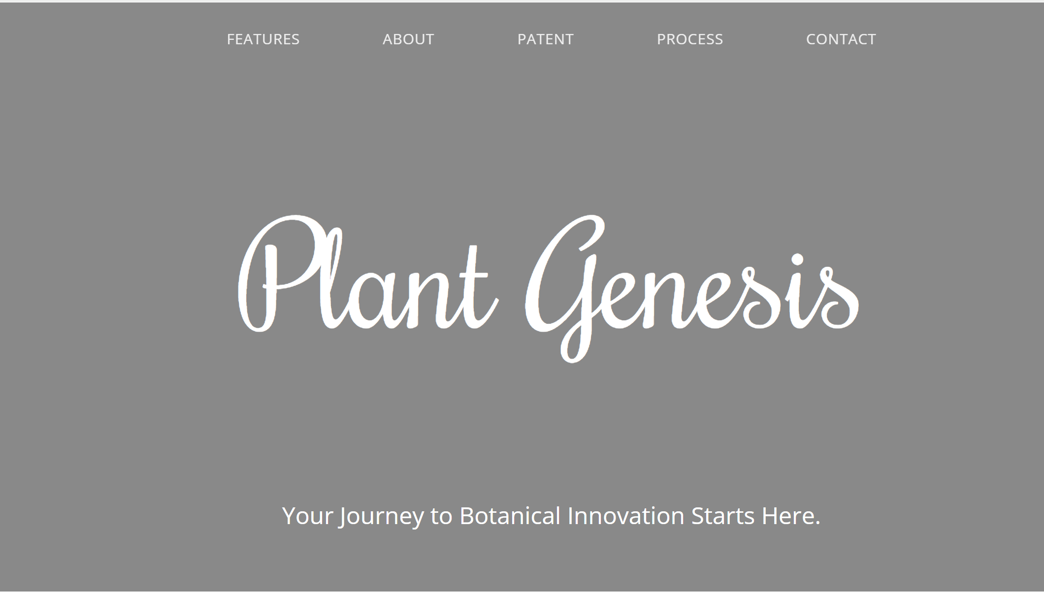

Figure 4.1

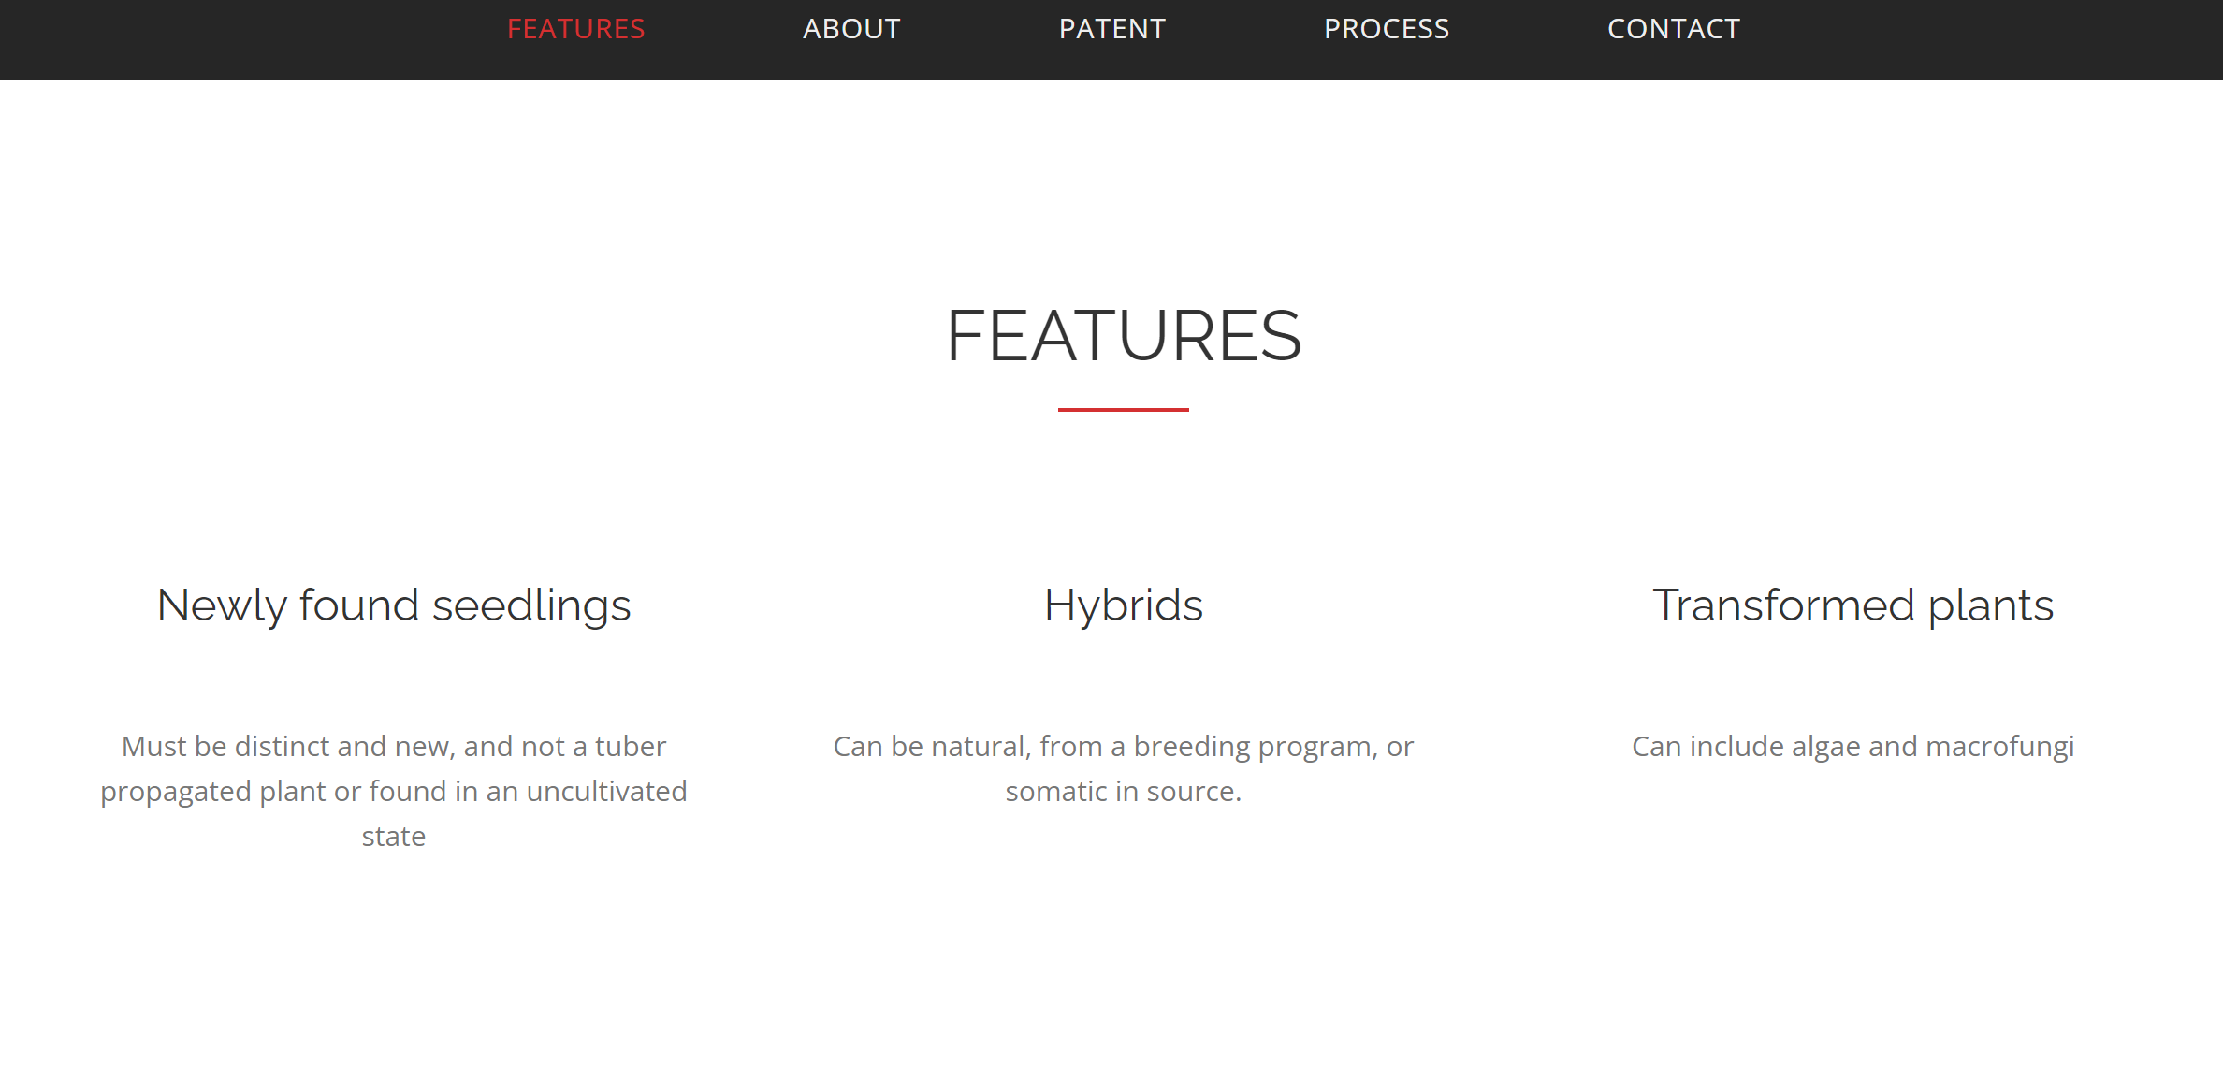

Figure 4.2

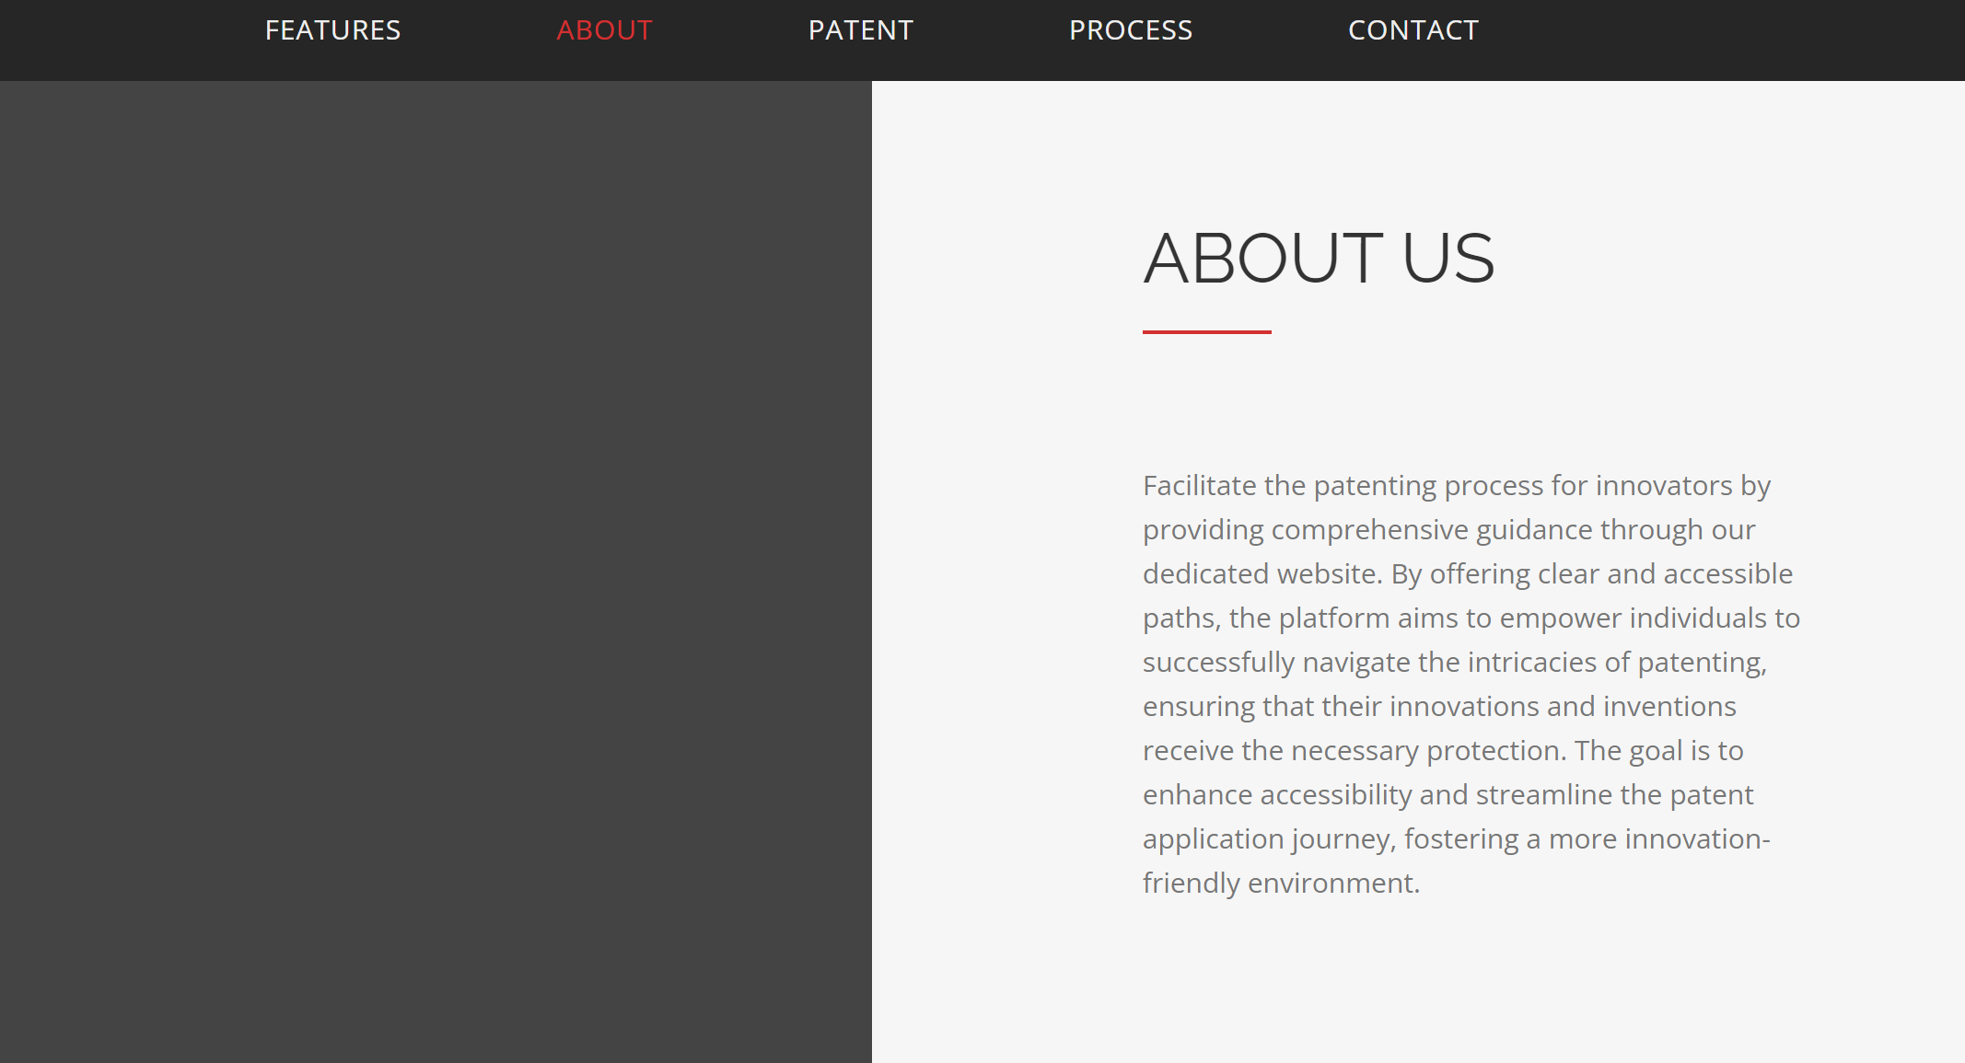

Figure 4.3

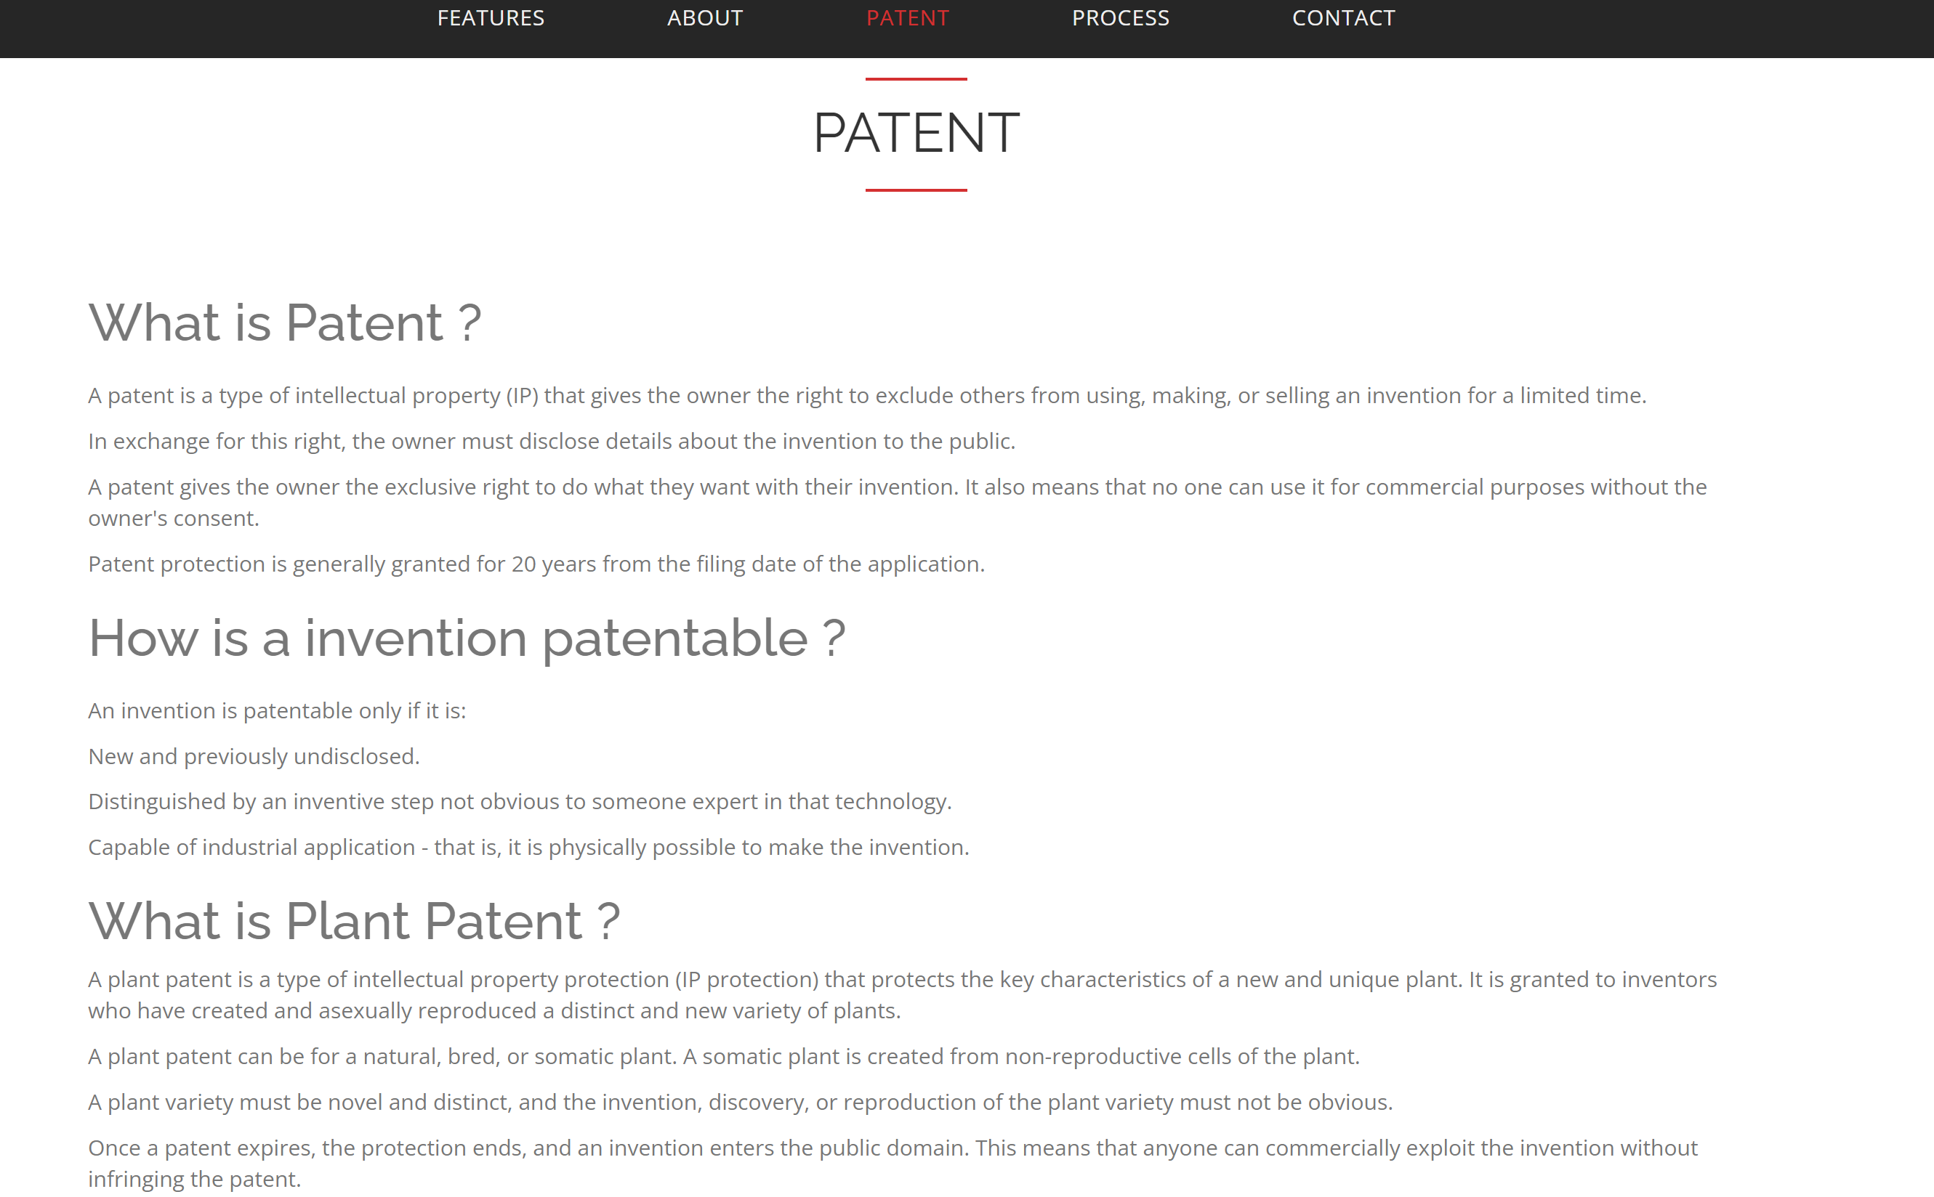

Figure 4.4
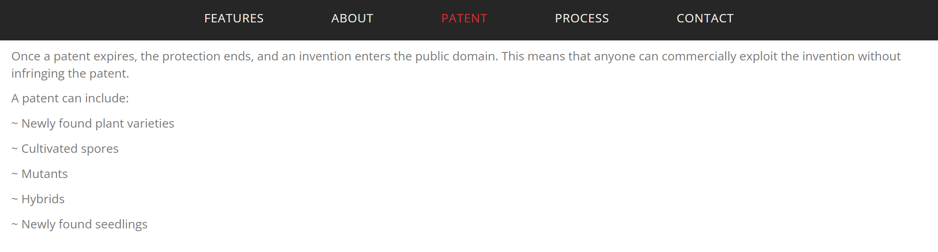

Figure 4.5

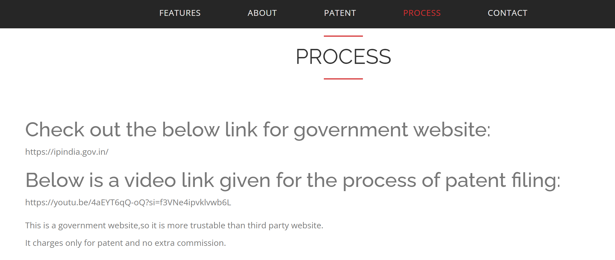

Figure 4.6

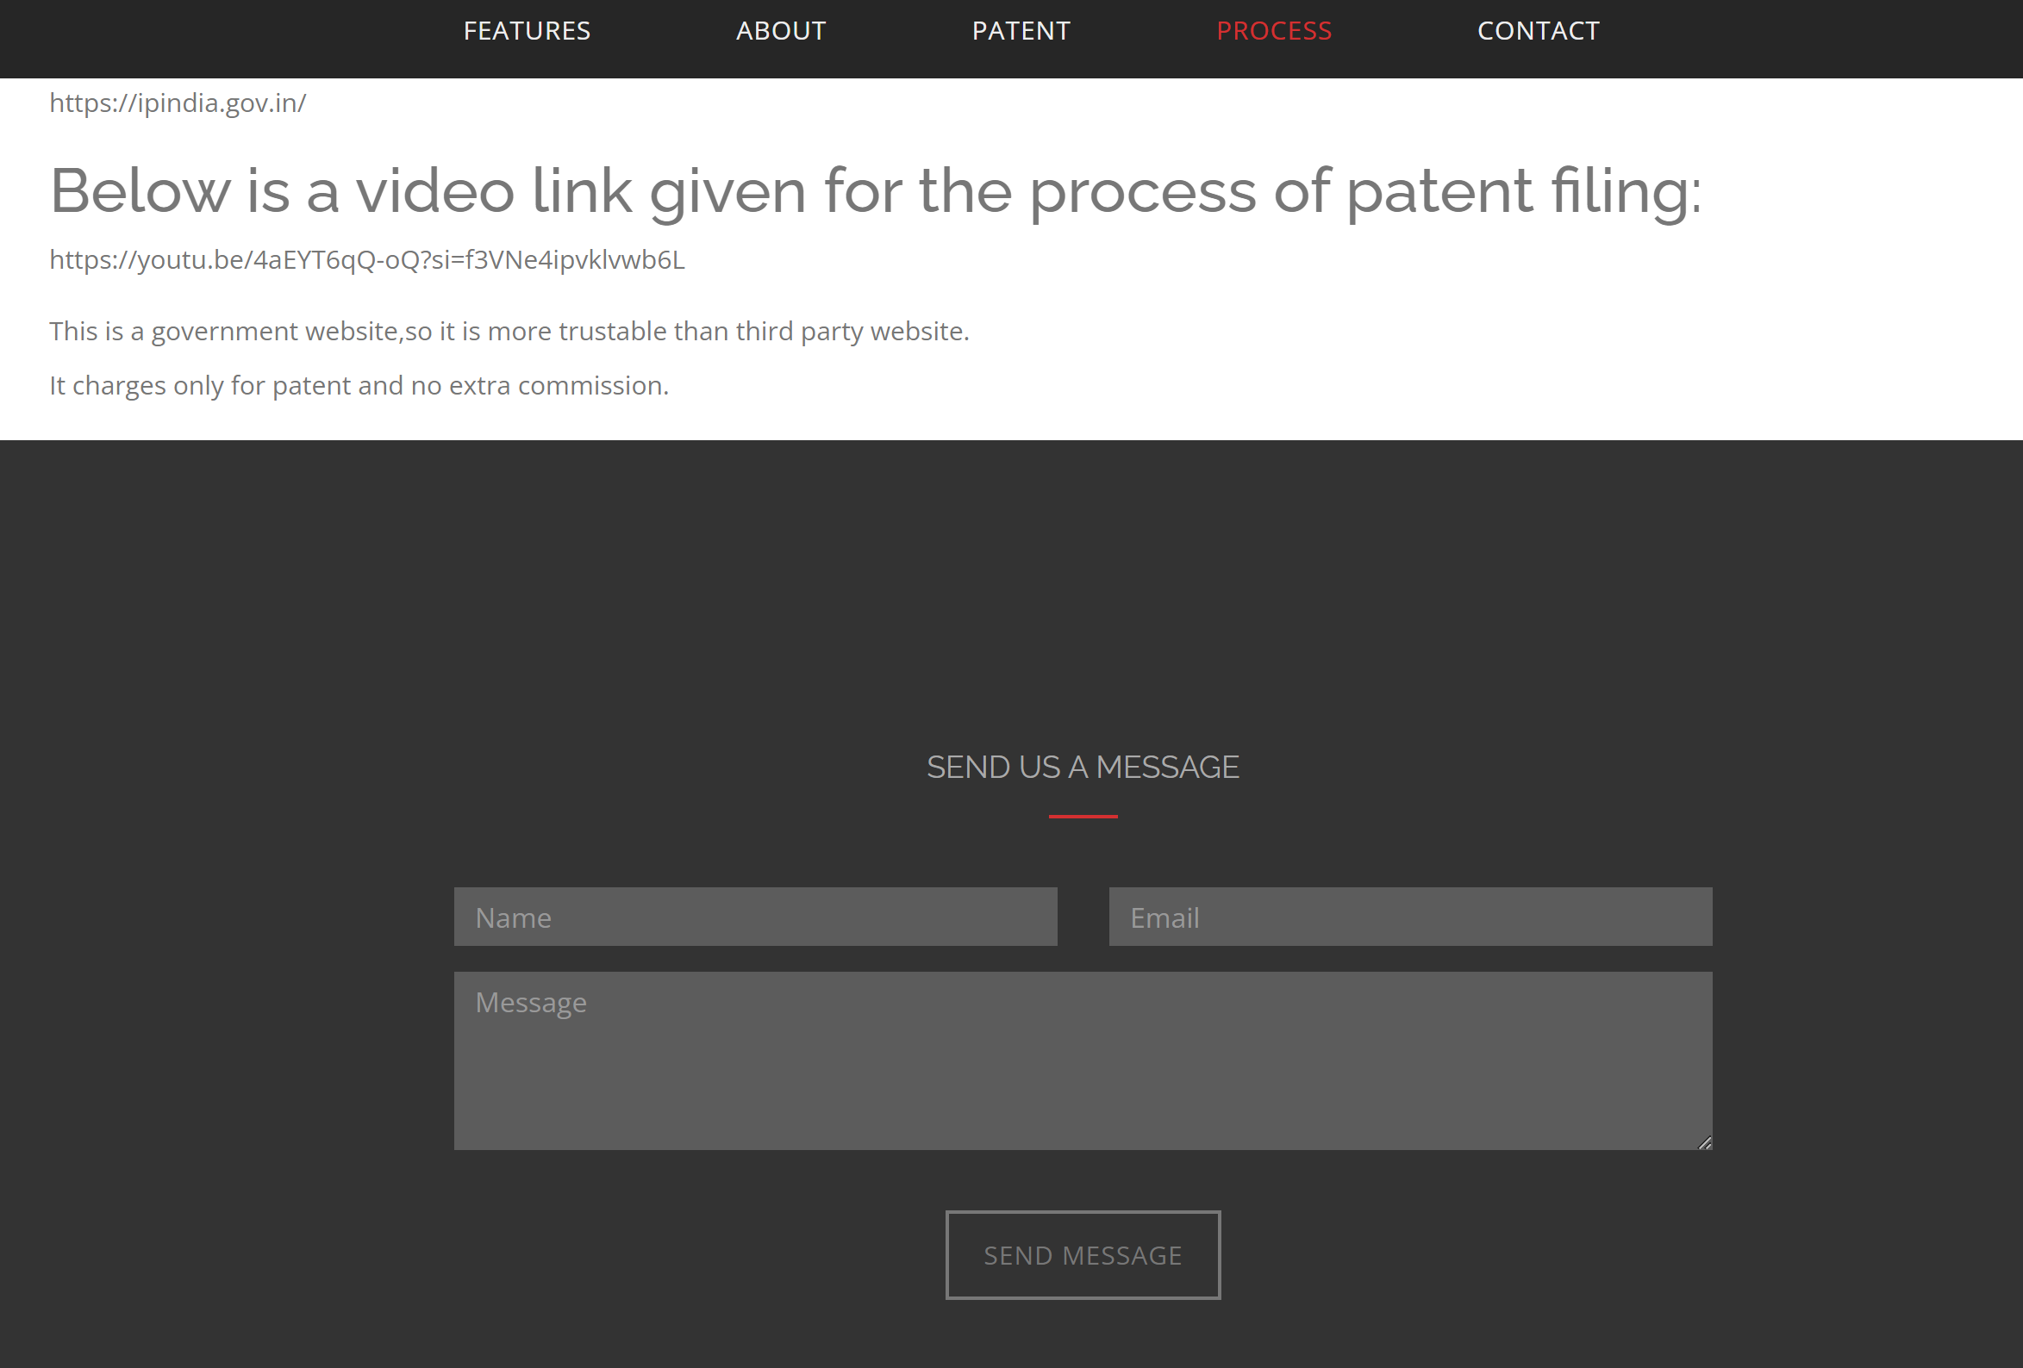

Figure 4.7

Database: 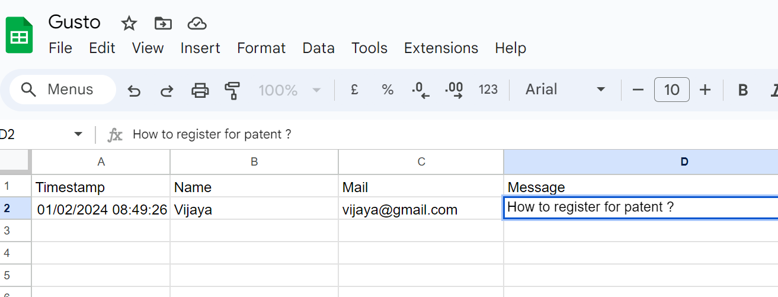

Figure 4.8

CHAPTER 5
TESTING AND DEPLOYMENT
Real-time Testing:
Conduct usability testing to ensure that the website is user-friendly and easy to navigate. Obtain feedback from potential users to identify any areas of confusion or difficulty in using the platform. Test all interactive features, such as registration forms, information retrieval, and navigation. Ensure that all buttons, links, and interactive elements work as intended across different devices and browsers. Implement security measures to protect user data and sensitive information. Perform security testing to identify and address potential vulnerabilities, ensuring the confidentiality and integrity of user data. Validate that the website functions correctly across various browsers (Chrome, Firefox, Safari, etc.) and devices (desktops, tablets, and smartphones). This ensures a consistent user experience for all users. Evaluate the website's performance by testing its response time, loading speed, and overall efficiency. Optimize the code and resources to enhance the website's speed and responsiveness. Verify the accuracy of the information provided on the website by cross-referencing it with reliable sources. Ensure that all details regarding plant patents and patenting processes are up-to-date and accurate.

Conclusion:
The development of an informative website dedicated to plant patents and patenting processes is a commendable initiative to bridge the knowledge gap in this critical area. Real-time testing has been crucial in ensuring that the website is not only informative but also functional and secure. The consolidated information on the platform, coupled with a user-friendly design, aims to empower individuals in navigating the complexities of plant patent registration efficiently. By providing clear guidance, the website contributes to a more informed and innovation-driven landscape in plant breeding and agriculture.

Future Enhancements:
Expand the reach of the website by incorporating multilingual support. This will make the information accessible to a broader audience, including individuals from diverse linguistic backgrounds. Integrate interactive tools or calculators that can help users determine the best-suited registration method for their specific plant innovations. This enhances user engagement and provides tailored guidance. Create video tutorials explaining different aspects of the patenting process. Visual content can be more engaging and effective in conveying complex information, catering to different learning preferences. Establish a community forum where users can interact, share experiences, and seek advice from experts or peers in the field of plant patenting. This fosters a collaborative environment and enhances the overall user experience. Keep the content on the website updated with the latest information and changes in plant patent laws and regulations. Regularly review and update the website to ensure its continued relevance and accuracy.

REFRENCE
https://www.uspto.gov/patents/basics/apply/plant-patent#:~:text=Additional%20Links-,What%20is%20a%20plant%20patent%3F,found%20in%20an%20uncultivated%20state.
https://www.epo.org/en/news-events/press-centre/fact-sheet/447625
https://www.investopedia.com/terms/p/plant-patent.asp
https://www.ams.usda.gov/rules-regulations/seed-liaison/patent-resources
https://digital.lib.umd.edu/plantpatents
https://corpbiz.io/learning/what-are-plant-patents-protecting-innovation-in-the-agriculture-industry/
https://research.missouri.edu/technology-advancement/tips-forms/patent-protection
https://www.wipo.int/patents/en/
https://www.slideshare.net/DrSumithaJ/plant-patentpdf
https://www.uspto.gov/patents/basics/patent-process-overview
https://www.southcentre.int/wp-content/uploads/2014/11/RP55_Patent-Protection-for-Plants_EN.pdf
https://www.worldipreview.com/contributed-article/india-the-demand-for-patenting-plants-and-seeds-in-india
https://www.mondaq.com/india/patent/1250982/patenting-of-plants-a-boon-or-a-bane
https://support.lens.org/knowledge-base/plant-patents/
https://www.iihr.res.in/indian-patents
https://agritech.tnau.ac.in/patents/patents_patents.html
https://indjst.org/download-article.php?Article_Unique_Id=INDJST312&Full_Text_Pdf_Download=True
http://www.nbpgr.ernet.in/pgs-503/013_patentability_plants.pdf
https://ili.ac.in/pdf/ss.pdf
https://www.toppr.com/ask/question/which-indian-plants-have-either-been-patented-or-attempts-have/
https://papers.ssrn.com/sol3/delivery.cfm/ssrn_id1114522_code985047.pdf?abstractid=1114522
https://blog.ipleaders.in/types-of-patents/

